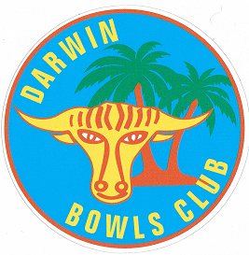

BAREFOOT BOWLS

CONDITIONS OF PLAY

Thank you for choosing our club to play bowls. In order to preserve our green in the best possible condition and for your own safety it is a requirement for everyone to adhere to the following rules.

1. **Only Thongs, Bowls Shoes, or Barefeet to be worn on the green**
2. **Drinks are not permitted on or near the green**
3. **Sitting on the bank at the edge of the green is not permitted**
4. **Children must be supervised at all times**
5. **No smoking on or near the green (Includes E cigarettes)**
6. **Bowls cases not permitted on the green**
7. **Chewing gum is not permitted on the green**
8. **Bowl is to be rolled from start to finish**

We are proud of our club and its facilities and hope you have a great time.

Don’t forget to tell your friends about our club.

Membership forms are available should you consider joining our club, have a chat to our friendly bar staff who will be happy to help.