PRESIDENTS MESSAGE
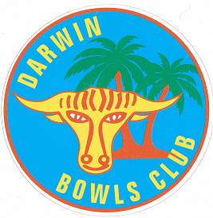
Fellow bowlers,

The Club’s first ‘Jack Attack’ event was held during November which proved very successful with 70 people participating. As a result the club will be running Jack Attack tournaments during 2016. While the finer details have to be discussed further expect that on one night a week for a period (four to six weeks) Jack attack will be played. For those not sure of the format of this exciting bowls game I have placed all you need to know on the notice board inside the club. More to follow on this once dates have been finalised.

Sheets are on the notice board for Handicap Pairs with singles to be placed up shortly. This year the pairs will be ‘Club selected’ with Tony Shelley, Mick Holdstock and Andy Cruse volunteering to be both handicappers and selectors. Games are set to commence on 31 January 16, so please get your names up so we can get some games underway early in the year. You will also notice that some rules have been placed up along side the sheets which are there primarily to ensure the club games are conducted in accordance with the calendar (out early January). Rules as follows:

- Games to be played on scheduled day.

- If for a legitimate reason (late notice call in to work, sickness, or injury) you cannot play on the scheduled day you may play prior to the next round as long as your opponent/s agree. If your opponents don’t or can’t play during the week, prior to the next round you will forfeit that game. Subs are fine but same conditions apply.

- If you know you are going away during the conduct of an event and can’t arrange a sub to fill in for you, the event will not be played around your movements. Rule two will apply. If you are not going to be in location during the entirety of a particular event maybe you shouldn’t enter.

- Future rounds of an event will not be played ahead of time (see rule one and two).

Posters have been placed up around the club outlining the acceptable dress code for both club games and bare foot bowls. As members of the club please assist your committee in ensuring these rules are complied with. It is your club!

As this will be last ‘message’ for the year I would like to take this opportunity on behalf of the Bowls Committee to wish you and your family a Merry Christmas and a Happy New Year. If you are going away over the festive season travel safe, particularly if you’re driving. 2016 will be a massive year so please come back in the New Year fully invigorated ready to face whatever the year brings.

Harry

Bowls Committee President

15 Dec 15

